|  |  |
| --- | --- |
| EGC_Black | Student Name \_\_\_\_\_\_\_\_\_\_\_\_\_\_\_\_\_\_\_\_\_\_\_    **Eastern Goldfields College**  Mathematics Applications 2015  Test 4 (U2 T1) – Calculator Free1 |
|  | **Total Marks: 26 marks** |

**Time allowed: 25 minutes**

**No calculator or notes permitted for this section.**

***Answer all of the following questions. Show all working to obtain full marks.***

**Question 1** **(5 marks: 1, 1, 1, 1, 1)**

Using the classifications listed below, classify each of the following variables and identify the best way to display them.

Classifications:

* Categorical and nominal
* Categorical and ordinal
* Numerical and discrete
* Numerical and continuous

|  |  |  |
| --- | --- | --- |
|  | **Data Classification** | **Data Display** |
| Gender |  |  |
| Number of Children |  |  |
| Finishing position in a 100 m race |  |  |
| Height |  |  |
| Height to the nearest cm |  |  |

**Question 2** **(7 marks: 1, 2 , 2, 2)**

Solve the following equations:

$2x-6 =14$

$3\left(6-2x\right)=28$

$\frac{3x}{10} = \frac{2}{5}$

1. $5- \frac{ 3x}{4}$ = 2

**Question 3** **(6 marks: 2, 4)**

(a) The mean height of a sports team is 182 cm. One of the players who is 172 cm tall leaves the team. Will the mean height increase, decrease or remain the same. Justify your answer.

(b) The whole numbers below are arranged in ascending order and have a mean of 6.

1, 3, , 6, 7, , 9, 10

Determine all the possible values for  and .

**Question 4**  **(4 marks: 1, 2, 1)**

A rectangular field is $x$ metres wide and $x+130$ metres long. The perimeter of the field is 520 metres.

1. Find an expression for the perimeter of the field.
2. Find the width of the field.
3. Determine the length of the field.

**Question 5** **(4 marks: 1, 1, 2)**

Paula had *n* marbles and Stephen had 11 less than Paula.

1. Write an expression for the total number of marbles Stephen had.
2. Write an expression for the total number of marbles.
3. If they had a total of 61 marbles, write an equation and calculate the number of marbles Paula had.

**End of Non-Calculator Section**

|  |  |
| --- | --- |
| EGC_Black | Student Name \_\_\_\_\_\_\_\_\_\_\_\_\_\_\_\_\_\_\_\_\_\_\_    **Eastern Goldfields College**  Mathematics Applications 2015  Test 4 (U2 T1) – Calculator Assumed1 |
|  | **Total Marks: 34 marks** |

**Time allowed: 35 minutes**

**Calculator and 1 x double sided A4 notes permitted for this section.**

***Answer all of the following questions. Show all working to obtain full marks.***

**Question 1** **(5 marks: 2, 1, 2)**

Jeremy sells sausages in bread outside Bunnings on Sundays. The number of sales each day over 30 Sundays was recorded as follows:

66 64 28 93 47 110 53 68 117 43

72 68 84 103 59 82 78 61 104 79

51 63 112 81 79 94 42 57 83 100

1. Draw a stem-and-leaf plot to represent this data
2. On what percentage of days did Jeremy have more than 50 sales?
3. What is the outlier? Give one possible reason for this outlier?

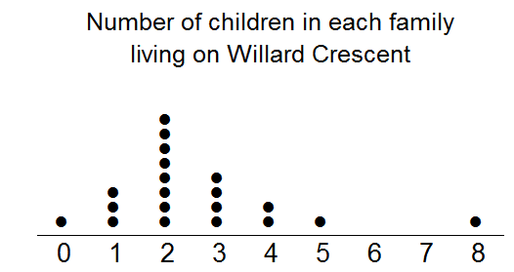**Question 2** **(9 marks: 1, 2, 1, 1, 2, 2)**

This dot plot shows the number of children in each family living on Willard Crescent.

1. How many families live on Willard Crescent?
2. Calculate the mean number of children per family.
3. What is the outlier?
4. If the outlier is removed from the data set, how is the mean affected?
5. Give two reasons why the mean is not a good measure of centre for this data.
6. An extra family moved into Willard Crescent, increasing the mean number of children to 3. How many children did the new family have?

**Question 3** **(2 marks)**

The mean of seven scores is 53.25. If six of the scores were 60, 50, 37, 60, 55 and 32, find the seventh score.

**Question 4** **(12 marks: 3, 1, 2, 2, 2, 2)**

The birth weights, in kilograms, of 12 baby **girls** are listed in ascending order below:

2.95, 3.00, 3.03, 3.06, 3.07, 3.10, 3.15, 3.25, 3.29, 3.41, 3.45, 3.49

(a) For these 12 weights, determine

(i) the mean

(ii) the median

(b) Briefly explain why the mode is not a suitable measure for indicating central location for this data.

The histogram below shows the birth weights of 16 baby **boys**.

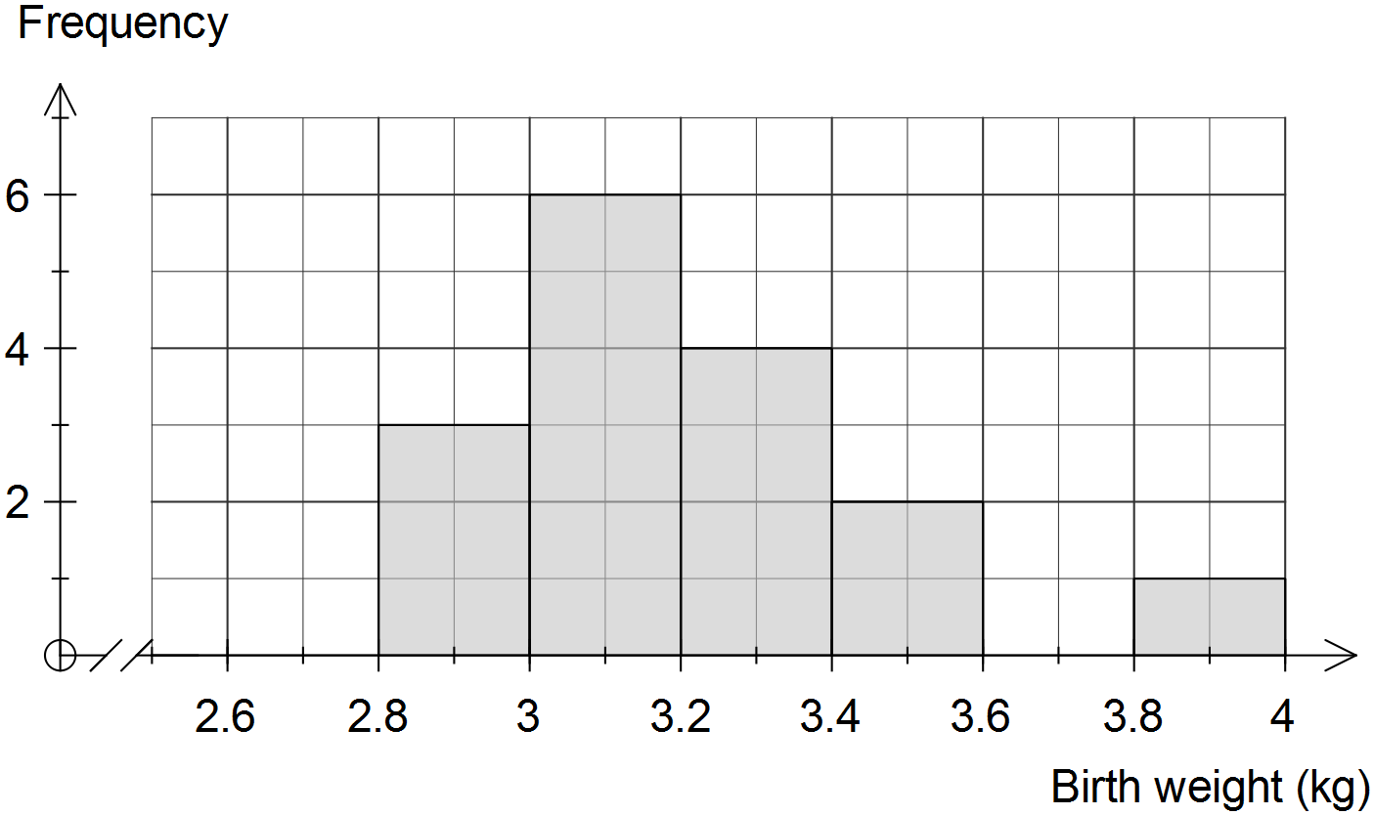

(c) Describe the spread of the weights of the 16 baby boys.

(d) Use the information on the previous page to complete the frequency table below for the **combined weights** **of all** 28 babies.

|  |  |
| --- | --- |
| Weight (kg) | Frequency |
|  |  |
|  | 5 |
|  |  |
|  |  |
|  |  |
|  |  |
|  |  |

(e) Estimate the mean weight of all 28 babies using the frequency table.

(f) Use the frequency table in (d) to construct a frequency histogram on the axes below.

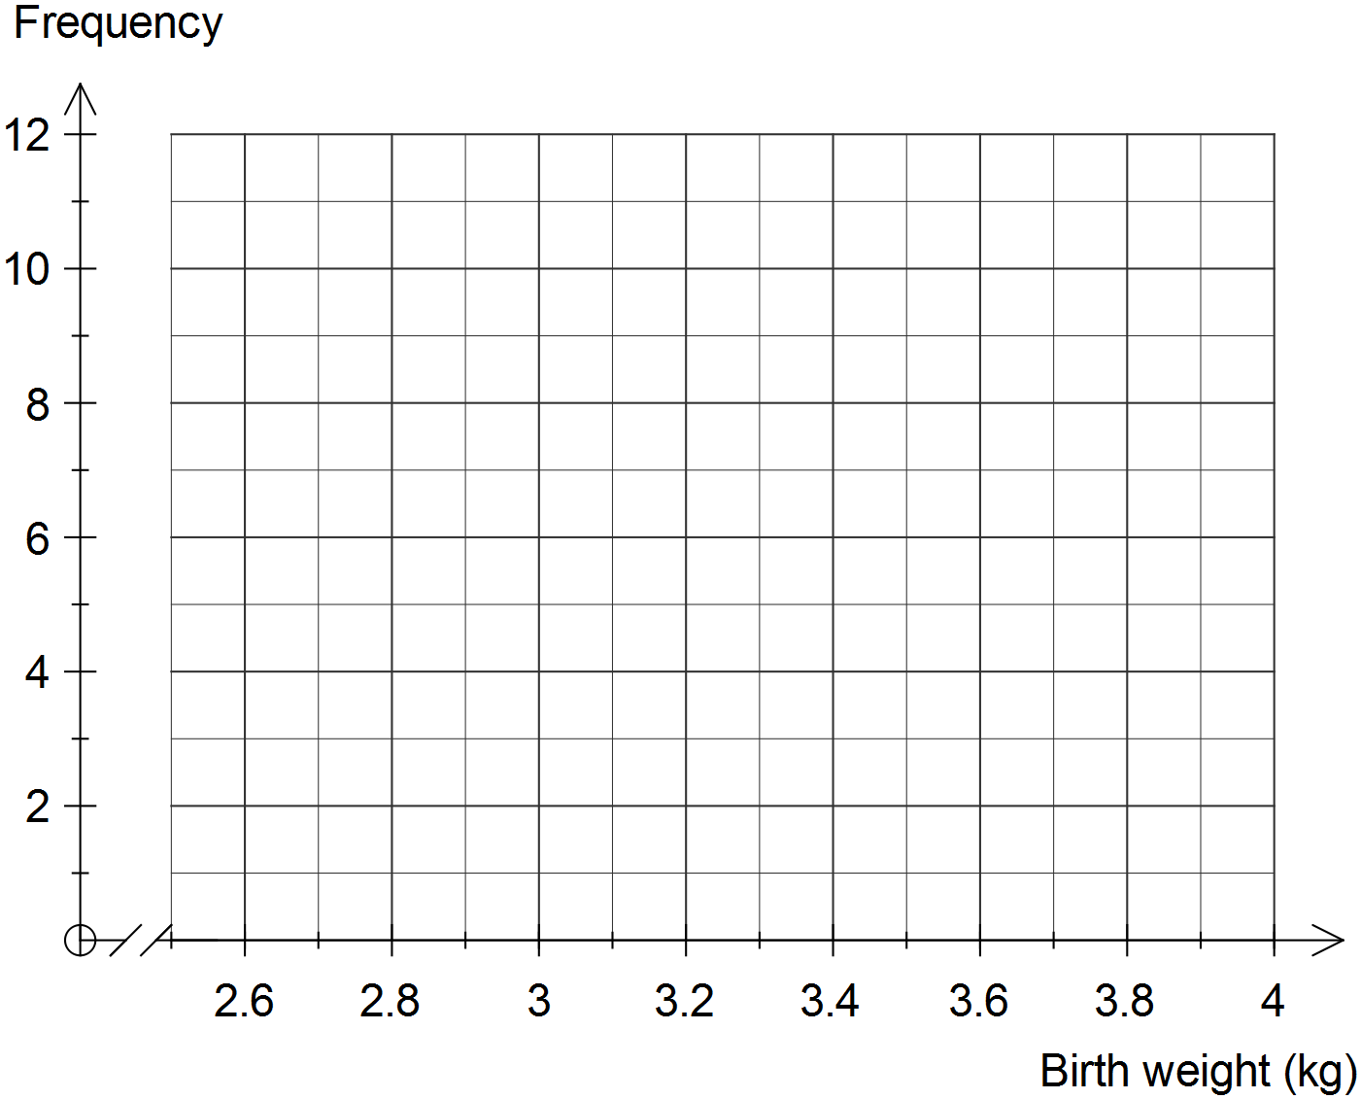

**Question 5 [6 marks: 1, 1, 2, 2]**

Two classes, class A and class B, sit the same test and the combined mean is 72%. Class A has 50 students in it and the class mean is 69%. Class B has a class mean of 78%

1. Determine the total of the scores for class A.
2. Write an expression to determine the total of the scores for class B, where $x$ represents the number of students in class B.
3. Using the combined mean of 72%, write an equation to determine the number of students for class B.
4. Determine the total number of students for class B.

**End of Calculator Section**